Techfest 2026-27
ContextCon IIT Bombay: The Agentic Services Hackathon
Sponsored by:
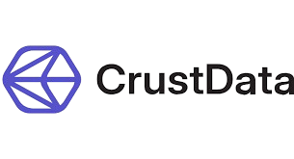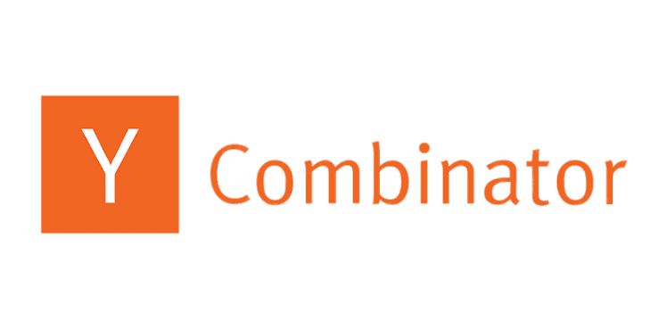
Objective:
The rapid proliferation of large language models has fundamentally shifted how work is executed, moving software from simple productivity tools to fully autonomous agents. While foundational models can reason and hold plans across hundreds of steps, specialized data infrastructure is required to turn complex professional services into software.
ContextCon IIT Bombay challenges participants to build autonomous AI agents that transform professional services, traditionally handled by teams of human professionals across hiring, investing, research, and compliance, into fully automated software solutions powered by agent-native data infrastructure. The objective is to reward root-cause understanding of complex domain workflows, agentic execution precision, and reliable verification capabilities over simple prompt wrappers.
Challenge Question:
How effectively can you design, build, and deploy autonomous AI agents that take a real-world professional service workflow, traditionally handled by entire firms, and execute it end-to-end with high precision, verifiable reasoning, and zero human intervention under strict time constraints?

Themes
- Hiring: Recruiters and staffing agencies paid on outcomes, finding candidates who fit and verifying their career history.
- Investing: Venture funds and banks analyzing startups, parsing data rooms, and pricing deals from historical points.
- Research and markets: Extracting answers from thousands of pages with verified source citations and forecasting market metrics.
- Insurance: Underwriting businesses, auditing policy coverages, and processing claim damages from unstructured evidence.
- Trust and compliance: Distinguishing genuine businesses from shell companies, setting credit limits, and running fraud analysis.
- Buying and paying: Automated procurement, purchase request conversion, and robust invoice processing.
- Agents that spend: Managing budgets, purchasing datasets or compute, and running authorized transactions autonomously.
- Supply chain: Managing shipments across borders, tracking inventory bills of materials, and handling legacy web portals.
- Revenue: Inbound lead routing, automated outbound outreach, and predictive forecasting.
- Infrastructure for agents: Building missing developer blocks such as long-term memory, rule-checkers, CRM bindings, or cryptographic execution trails.

Track-Specific Specs/Deliverables
- Data Integration: Must integrate and build on top of Crustdata's canonical identity graph for people and company data.
- Core Deliverable: A functional repository and a two-minute demo video showcasing the product taking a request it has never seen all the way to finished work.
- Modes of Interaction: Can be architected as a single agent, a system of agents, an MCP (Model Context Protocol) server, or a CLI.

Track-Specific Environment Stack
- Data Provider API: Crustdata API endpoints ([https://api.crustdata.com](https://api.crustdata.com)) including Person Search, Person Enrich, Company Search, Company Identify, Company Enrich, Job Search, Web Search and Fetch, and Watcher.
- Headers Required: authorization: Bearer YOUR_API_KEY and x-api-version: 2025-11-01.
- Agent Integration: Support for Model Context Protocol (MCP) servers for agentic pipelines.

Format of Competition & Evaluation Criteria
- Format: A single-day, intensive 5-hour build sprint followed by video evaluation and live on-stage finals.
  - Phase 1 (Review & Shortlisting): Every team's submitted demo video and code repository are reviewed to shortlist finalists.
  - Phase 2 (Live Stage Finals): Finalist teams pitch and demonstrate their agents live on stage at IIT Bombay.
- Evaluation Criteria:
  - End-to-End Execution: Does the agent take a request all the way to finished work without human intervention?
  - Data Integrity & Verification: How well does the solution leverage Crustdata's canonical graph and maintain verifiable citations for every claim?
  - Robustness & Edge Cases: How effectively does the agent handle messy real-world data constraints, unformatted inputs, and unexpected tool responses?
  - Demo Clarity: How clearly does the two-minute demo video or live presentation showcase the workflow results?

Team Specification and Eligibility
- Eligibility: Open to third- and fourth-year BTech, dual-degree students, and MTech students at IIT Bombay.
- Team Size: Individual participation or teams of up to 4 members.

Timeline and Key Dates [tabular format only]
Event | Date & Time
Doors Open & Badge Collection | 31 October 2026, 9:00 AM
Official Kickoff & Theme Briefing | 31 October 2026, 9:30 AM
Crustdata API Walkthrough & Team Formation | 31 October 2026, 10:00 AM
Building Begins (Code Start) | 31 October 2026, 10:30 AM
Lunchtime Lightning Talks | 31 October 2026, 12:30 PM
Optional Mentor Checkpoint | 31 October 2026, 1:30 PM
Last Call (30 min to code freeze) | 31 October 2026, 3:00 PM
Code Freeze & Submission Deadline | 31 October 2026, 3:30 PM
Video Review & Evaluation | 31 October 2026, 3:45 PM
Finalists Announcement | 31 October 2026, 5:00 PM
Live Stage Finals & Judging | 31 October 2026, 5:30 PM
Winners Announcement & Closing Party | 31 October 2026, 7:30 PM

Gameplay or General Rules of the Competition
- All teams must register through the official Y Combinator event platform link provided by Techfest, IIT Bombay.
- Preparation of ideas, system sketches, and architecture blueprints beforehand is allowed; however, actual coding begins strictly at 10:30 AM on 31 October 2026.
- Every participating team must utilize Crustdata's API keys and identity graph during the build.
- During the event, agents are strictly restricted from interacting with external real people; they must interact only with the team's local environment and authorized APIs.
- Submissions must include a functional code repository and a 2-minute screen recording demo video submitted by 3:30 PM.
- Decisions made by the judges and organizing committee are final and binding on all participants.

Certificate Policy
- Certificates of Excellence: Awarded to the top 3 winning teams of the final round.
- Certificates of Merit: Issued to all finalists and active onsite participants.
- Certificates of Participation: Issued to all registered teams with valid submissions.

Prize Money
- First Place: $8,000 in Crustdata credits
- Second Place: $3,000 in Crustdata credits
- Third Place: $1,000 in Crustdata credits
- Top Three Teams: Exclusive 1-on-1 office hours with Jon Xu, Partner at Y Combinator
- Every Participating Team: $1,500 in Crustdata API credits for hackathon development
- Standout Builders (Any Team): Eligible for a pre-placement interview opportunity at Crustdata

